BOB SPUTTERING TOOL
August 06 2014

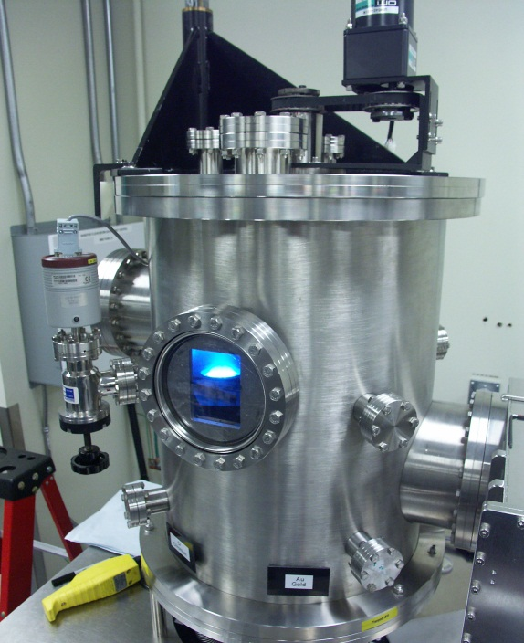

Location: 10K PVD area
Primary Trainer: Les Schowalter (587-879-1516), les.schowalter@ualberta.ca)
Secondary Trainer:

OVERVIEW
A planar magnetron sputter system with three sources. The gun/substrate configuration is designed for sequential sputtering. The third source can be used for magnetic materials.

SAFETY PRECAUTIONS
When using the hoist to close the system take care that your fingers are not between the chamber lid and body. Some materials are not compatible with a vacuum system; if you aren’t sure of your material please see the primary trainer.

If you are bringing any new materials into the NanoFab for use in your process, it is necessary to fill out a chemical import form (available on our website, http://www.nanofab.ualberta.ca) and supply an MSDS data sheet to Stephanie Bozic.

OPERATING INSTRUCTIONS

Opening & Loading

1.0 Press “emis” on the multi gauge controller to turn off the ion gauge then press “channel” until TC1 is shown and nothing on the bottom right.
2.0 Turn the Baratron valve clockwise until closed.
3.0 Close the cryopump valve clockwise until closed; there should be a solid click sound when closed. Also note the cryopump temperature, if it’s not below 20K please inform nanoFAB staff.
4.0 Flip the chamber vent switch up. When the pressure readout is at 760 Torr the chamber should be at atmosphere and the chamber vent switch must be closed.
5.0 Lift the lever on the back of the chamber lid.
6.0 Press the up button on the hoist and raise the top of the chamber until the substrate holder is clear of the main chamber, and then move the chamber top away.
7.0 Please put gloves on for the next steps.
8.0 Check the inside of the chamber for flaking and other debris; vacuum as required.
9.0 If the glass view port is coated with metal, pull out and replace glass. Please use IPA to clean all six sides of glass before installing.
10.0 Change targets as required, check to see if the proper target is in the chamber or in the correct container. Sputtering the wrong material may set your project back.
11.0 Make sure the dark space shield has adequate spacing. Most targets are ¼” thick and the dark space shield shouldn’t be on any notch, Targets such as Au and Pt are thinner and should go onto the smallest notch. Check spacing with the voltmeter, you should have an open circuit.
12.0 Close the shutters. Remove any particles around the main o-ring using a cleanroom wipe and IPA.
13.0 Load your substrate(s) and move the top over the chamber; move the lever down and press the lower button on the hoist. Make sure you hold onto the top section as it wants to move to the right. When the top meets the chamber stop pressing the lower button, it can’t lower any further!

Pump down

1.0 Open the chamber roughing valve about one full turn and observe if the chamber pressure is dropping. If the pressure doesn’t change, check to see if the lid is properly seated onto the chamber. If pressure still doesn’t drop close roughing valve and find nanoFAB staff to look into the issue.
2.0 Rough to about 350 Torr then open the roughing valve all the way then close about a half turn. Rough out to 3.0X10⁻¹ (about five minutes depending on which roughing pump is used.) then close roughing valve.
3.0 Slowly open the cryo valve all the way by turning counterclockwise.
4.0 Open the Baratron valve by turning it counterclockwise.
5.0: Press “channel” on the multi gauge controller until BA1 is shown in the lower right of the display, then press “emis”.
6.0 Pumpdown takes about one hour to reach the low -6 Torr.
7.0 Write your deposition parameters in the logbook, and put the sputter system in use sign up.

Deposition

1. Press “emis” on the multi gauge to turn off the filament, then press “channel” until aux1 is shown in the lower section of the display.
2.0 Pull and lift the power switch on the MKS controller, then lift switch 1 for Ar gas, close the cryo gate valve about four turns until the Multi gauge controller reads 7X10⁻³ Torr.
3.0 Put target selector switch to the desired target. Switch on the power on the back of the MDX 500 power supply; adjust the power setting required for the material you are depositing. Remember the power supply should only be used in power mode.
4.0 Set substrate rotation to the desired speed, three to four is normal. Press the rotation switch.
5.0 Set a timer for the deposition time plus preconditioning. Target conditioning is usually three minutes except for Pt and Au which is one minute.
6.0 Press start on the power supply to condition the target. Look in the chamber to make sure the shutter is closed.
7.0 After the target conditioning step is over gently open the shutter and deposit for the desired time. Remember to write the voltage in the logbook. Press stop on the power supply when the desired time is reached.
8.0 Close the shutter and repeat steps three to six if another metal is required.
9.0 After the deposition is completed, turn off MDX 500 power supply (switch at the back).
10.0 Stop substrate rotation.
11.0 Turn target selector switch to off.
12.0 Turn off Argon switch, and MKS master power.
13.0 Press “channel” on the multi gauge controller until TC1 is shown and nothing else in the lower right section of the display.
14.0 Close the Baratron valve.
15.0 Close the cryo gate valve.
16.0 Flick the chamber vent switch to put a few Torr of N₂ in the chamber then wait five minutes before venting.
17.0 After venting, open chamber using the same instructions as opening and loading starting at step #5. Put gloves on after moving the chamber top, remove substrate(s) and inspect chamber for flaking. If flaking is discovered please vacuum.
18.0 If you used a Pt target, please remove it from the system.
19.0 Follow steps from pumpdown section. Please note that you don’t have to start with slow pump down.

TROUBLESHOOTING
If you can’t get a plasma do the following:
Close the cryo gate valve to the point of causing resistance.
Change power setting to 50 watts.
If you still can’t get a plasma find the trainer for the tool or other nanoFAB staff to look into the issue.

If you encounter an unexpected error or require assistance please contact the primary or secondary trainer listed above. Should they not be available, please contact any staff member for assistance.

APPROVAL

Qualified Trainer: Les Schowalter
Training Coordinator: Stephanie Bozic

