**Plasma-Therm Versaline PECVD is Available**

The nanoFAB is pleased to announce that the new [Plasma-Therm Versaline PECVD](http://www.plasma-therm.com/versaline-pecvd.html) (Plasma Enhanced Chemical Vapor Deposition) system is fully commissioned and available for user training.

Thin films available for deposition include α-Si, SiNx – (Low stress and Stoichiometric), SiO2 and SiOyNx (silicon oxynitride). This PECVD has a user-friendly software and offers tunable index/stress control. The available process and carrier gases on the system are: 100% SiH4, NH3, N2O, H2, Ar, He and N2.

**The films resulting from this PECVD feature:**

* High uniformity
* Low particulates
* Increased productivity with short clean cycles
* Conformal films

The system is integrated with a multi-functional endpoint capabilities using EndpointWorks software. The simple interface for the OEI (optical emission inferometry) provides real time deposition rate information, and the OES (optical emission spectroscopy) decreases the period of the clean cycles between processes significantly.

**Some uniformity results for each of standard recipe/material are demonstrated below (Filmetrics was used to acquire the thickness maps):**

Recipe name: [a-Si Dep](https://confluence.nanofab.ualberta.ca/display/EQ/PT+PECVD+a-Si+Standard+Recipe+Information), Goodness of fit: 98.7%

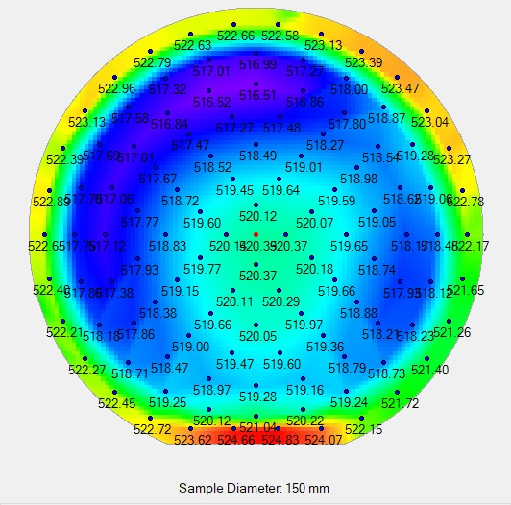

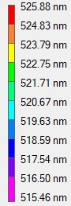

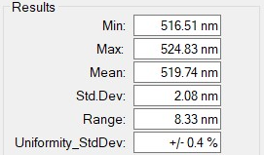

Recipe name: [LSN Dep](https://confluence.nanofab.ualberta.ca/display/EQ/PT+PECVD+LSN+%28Low+Stress+Nitride%29+Standard+Recipe+Information), Goodness of fit: 99.9%

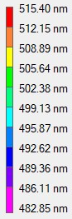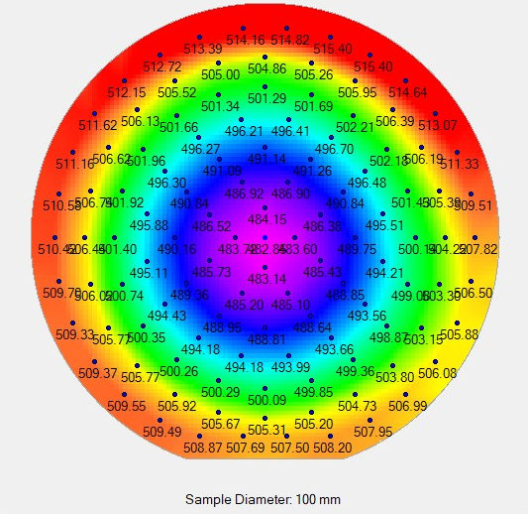

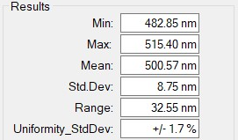

Recipe name: [Stoichiometric Nitride Dep](https://confluence.nanofab.ualberta.ca/display/EQ/PT+PECVD+Stoichiometric+Nitride+Standard+Recipe+Information), Goodness of fit: 99.1%

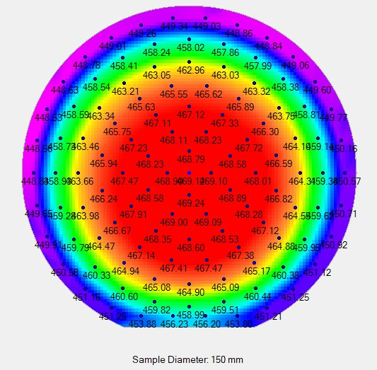

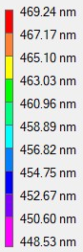

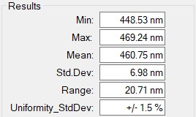

Recipe name: [SiO2 Dep](https://confluence.nanofab.ualberta.ca/display/EQ/PT+PECVD++SiO2+Standard+Recipe+Information), Goodness of fit: 99.9%

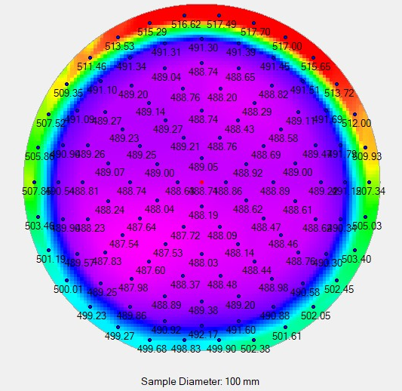

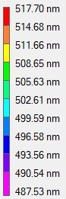

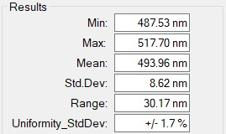

**Manufacturer boasts an extensive process library, and some trends for tuning of refractive index and stress have been shared below:**

#### ****a-Si Trends****

* Deposition rate increases with increasing pressure, and the film stress can be modulated from compressive to tensile by increasing the pressure. One point to note is that OEI does not work well with a-Si films because of its highly absorbing nature.

#### 

#### 

#### ****SiO2 Trends****

* Increasing the SiH4 flow rate and RF power will result in a higher deposition rate.





* Increasing the amount of N2O will decrease the refractive index, to a minimum of 1.46, while decreasing the N2O/SiH4 ratio will result in a higher refractive index.



#### ****SiON Trends****

The new capability of depositing silicon oxynitride (SiOyNx) films using this PECVD is exciting. SiON is a promising material investigated for development of passive optical components such as integrated waveguide applications, anti-reflective coatings, interferometers, filters, couplers, and splitters.

* Decreasing the N2O / SiH4 and N2O / NH3 produce nitride-like films, whereas increasing the ratios produces oxide-like films.

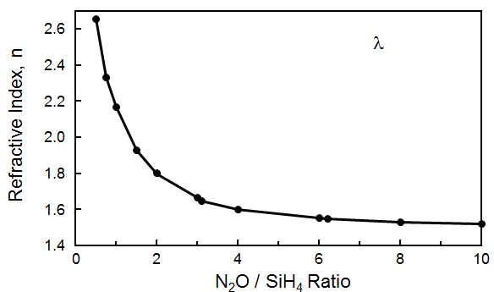

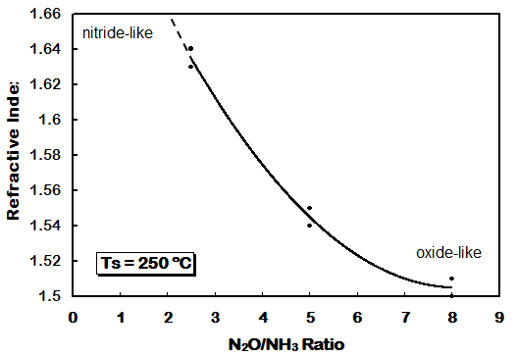

* A study of stress versus refractive index showed that a zero value stress could be achieved for an almost oxide-like refractive index (1.55) film.

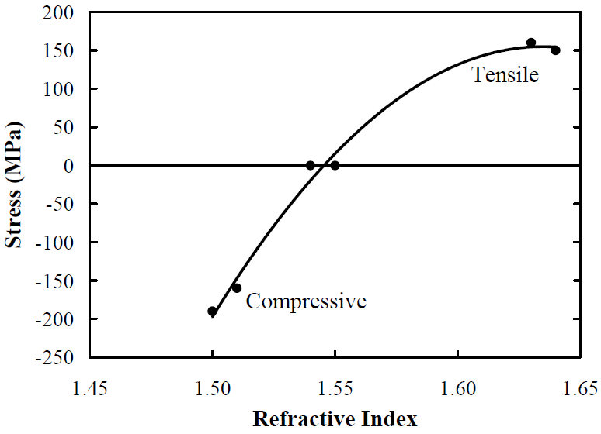

**Another major advantage of using PECVD instead of LPCVD furnaces for SiNx layer depositions is that you can deposit at lower temperatures and the processing time is significantly decreased. Take a look below at graphs comparing our standard recipes on both systems.**